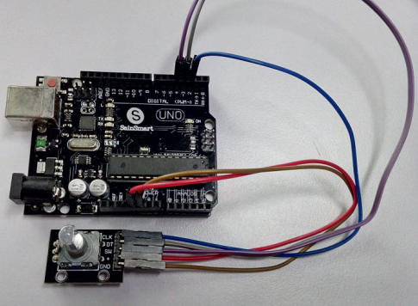

#define SERIAL_BAUDRATE 115200

#define CLK_PIN 2 // define connection pin

#define DT_PIN 3

#define SW_PIN 4

#define interruptA 0 // UNO pin2 is interrupt 0，refer to the official website of other board

volatile long count = 0;

unsigned long t = 0;

void setup() {

Serial.begin(SERIAL_BAUDRATE);

// when the state is down, the rotary encoder is rotated.

attachInterrupt(interruptA, rotaryEncoderChanged, FALLING);

pinMode(CLK_PIN, INPUT_PULLUP); // Input mode and enable internal pull up resistor

pinMode(DT_PIN, INPUT_PULLUP);

pinMode(SW_PIN, INPUT_PULLUP);

}

void loop() {

if(digitalRead(SW_PIN) == LOW){ // Press the switch, return to zero

count = 0;

Serial.println("count reset to 0");

delay(300);

}

}

void rotaryEncoderChanged(){ // when CLK_PIN is FALLING

unsigned long temp = millis();

if(temp - t < 200) // remove bounce

return;

t = temp;

// DT_PIN state represents a forward or reverse.

count += digitalRead(DT_PIN) == HIGH ? 1 : -1;

Serial.println(count);

}

